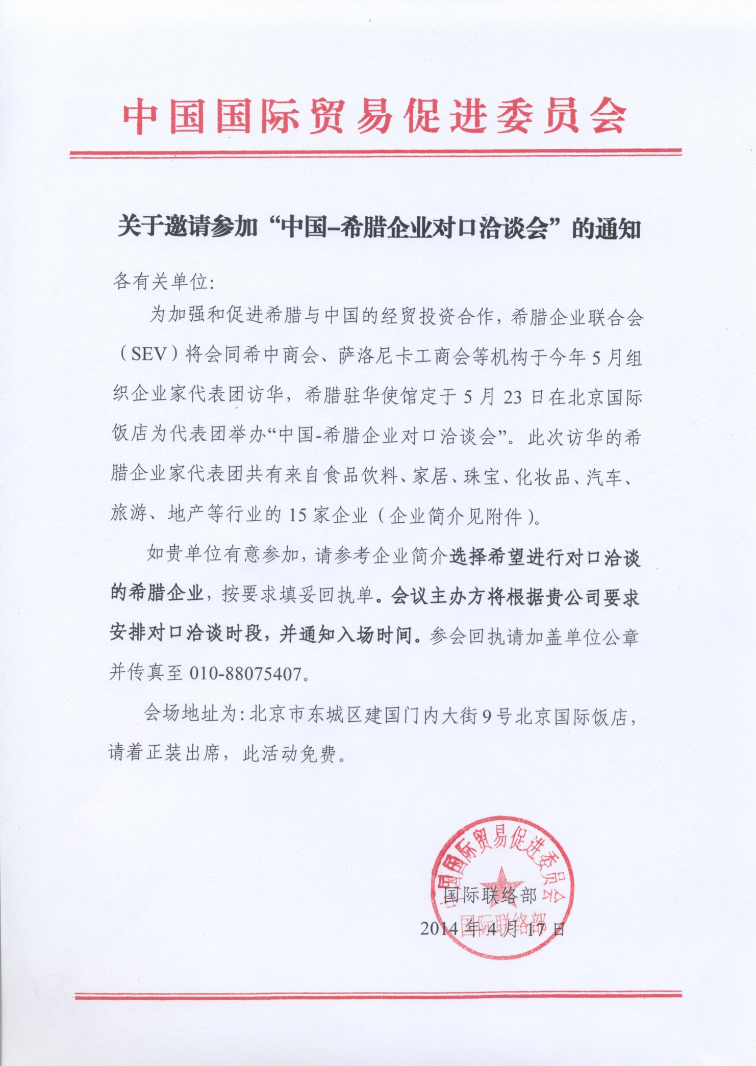
“中国-希腊企业对口洽谈会”参会回执

公司名称：中文
英文
业务范围：
公司地址： 邮编：

参会人员姓名： 拼音：
职务：
参会人员姓名： 拼音：
职务：
联系人： 电子邮件：
电话： 传真： 手机：
希望与以下希腊企业对口洽谈（请按附件代表团名单填写序号）：

请将回执于5月5 日前传真至我处。
联系人：徐添、章琪 电话：88075619，88075669
电子邮件：xutian@ccpit.org，zhangqi@ccpit.org 传真：88075407

单位盖章处

No | Company | Participant | Position | Compn profile | Cooperation request
1 | HELLENIC WINE LTD | BAIRAKTARIS John | MANAGING DIRECTOR | • Katogi & Strofilia : White , Red And Rose Wines  • Elea Creta : Extra Virgin Olive Oil With Max. Acidity 0,5%  ◊ Specialty : Extra Virgin Olive Oil With Natural Extract Of Basil, Lemon , Oregano , Garlic  • Pelopos Nissos Ores : Extra Virgin Olive Oil With Maximum Acidity 0,4%  ◊ Organic Extra Virgin Olive Oil With Max. Acid. 0,4% | 寻求进出口合作伙伴，尤其是橄榄油和葡萄酒的进口商
2 | PANAGIOTOPOULOS WINES | PANAGIOTOPOULOS Dimitris  FLERIANOS Yiannis | CEO  Winemaker | Vineyards and Winery in Messinia, Peloponnesos. Indigenous and international varieties: Malagousia, Fileri, Merlot, Cabernet Sauvignon. Numerous awards and medals in international competitions, including China. | 寻求葡萄酒进口商或合资合作
3 | PELOPAC SA | CONSTANTINIDIS Constantinos | MANAGING DIRECTOR | Pelopac is a manufacturer of high quality Mediterranean and Greek food products. Our range includes olives, antipasti, sauces, spreads and snacks. We supply leading brands and retailers in the USA, Australia and Europe. | 希望寻找食品进口商、代理商，并共同开发中国、香港、东南亚市场
4 | KELEON OLIVE PRODUCTS | KARAVIOTIS MICHAIL | MARKETING MANAGER | Keleon produces and trades premium quality olive oil and gourmet foodstuffs. Our products are currently sold to delicatessen and 5 star hotels. | 希望寻找食品饮料的进口、批发、分销商，同时希在上海寻找代理
5 | GEA TRADE | CHARALAMBIDIS Alexandros | Acount Manager |  | 希望与超市、食品进口和分销商合作
6 | ATHENIAN BED MATTRESS MANUFACTURING S.A. | PAPILIDIS Stefanos | INTERNATIONAL BUSINESS DEVELOPMENT SUPERVISOR | • Media Strom is one of the most powerful and predominant mattress and bedroom furniture companies internationally, with experience and unique expertise. The company was established in 1967 and for more than 40 years guarantees the impeccable manufacturing of products for sleeping purposes maintaining the motto "Sleeping is Living". | 寻求床垫等产品的进口和分销商，愿探讨合资或特许经营等合作
7 | PERIDEO SA | KARVOUNIDIS Panagiotis | GENERAL MANAGER | Perideo SA is a company that manufacture, import and export silver jewellery, watches and fashion jewellery.  There are two fashion brands that belong to the group of Perideo, Oxette and Loisir.  Oxette was established in 1998 and it soon become one of the leading brands in the global jewellery, watch and accessories market. Oxette is expanding worldwide. Today the brand is present in more than 20 countries via corporate and franchise shops in key points of the global map. | 希望探讨特许经营合作，与愿在中国大陆和香港开设Oxette品牌专卖店的企业洽谈。双方也可探讨在华设立合资公司共同开拓市场，甚至入股Perideo总公司等深度合作。
8 | ORIGANUM COSMETICS S.M.P.C. | ZAGANA Sophia (Mrs)  NIKOLAKES Nikos | OWNER - EXECUTIVE MANAGER  SALES MANAGERR | High class cosmetic products: Face cream, Face serum, Body cream, Body oil with Greek Origanum Extract. | 寻求化妆品进口商，探讨合资等合作事宜
9 | GRANTEX S.A. | PASCHALIDIS Theodore | MANAGING DIRECTOR | FRICTION MATERIALS MANUFACTURER. BRAKE PADS AND BRAKE LININGS FOR ALL HEAVY DUTY VEHICLES (TRUCK, TRAILERS, BUSES ETC.)  DEALER OF SPARE PARTS FOR THE BRAKE SYSTEM (AXLE PARTS, SUSPENSION PARTS, AIR BRAKE PARTS) | 寻求刹车片、制动衬片、车轴零部件、悬挂系统等汽车零部件的供应商或顾客。可就进出口或合资事宜进行洽谈。
10 | MAGIQ DOORZ | XANTHOPOULOU Kalliopi (Mrs) | NEW BUSINESS DIRECTOR | Integrated Communication agency, export marketing services | 寻求食品或有机化妆品的进口商和分销商，并希望与广告或公关公司商谈组建合资公司在华推广希腊产品的事宜
11 | KALAMAKI TRAVEL GENERAL TRAVEL AGENCY | DESPOTAKIS Miltiades | OWNER OF THE TRAVEL AGENCY |  | 希会见中国的旅行社，探讨赴希旅行团合作
12 | SANTORINI TOURS-ECORAMA HOLIDAYS-SANTORINI SHUTTLE | ZERVAS Alexios | C.E.O. | Travel Agency established in 1995, that owns its own transportation company and Hotels | 希会见中国的旅行社，探讨赴希旅行团合作，并在华设业务代表。也可探讨合资事宜。
13 | LEVENDI SA | LEVENDI Roula (Mrs) | MANAGING DIRECTOR | Hotel & Real Estate | 欲与中国房地产商、中介、移民咨询机构探讨出售本公司酒店和度假公寓。同时愿与从事橄榄油、橄榄、奶制品、意大利面、希腊乳香胶等产品进口的企业洽谈。
14 | SIKALIDIS REAL ESTATE | SIKALIDIS Lefteris | FOUNDER & CEO | Real estate consulting services for development and investment activities in the commercial and residential sector. Business consulting services. | 希与移民咨询机构、有移民业务的律师事务所、海外房产中介等洽谈合资、代理、投资合作等事宜。旅游合作，鱼类进口和分销。
15 | PAPAMANOLS DEVELOPMENT | VALSAMIS Maria (Mrs) | SALES MANAGERR | real estate developer of plots, residences,office buildings | 希与住宅和写字楼开发商、移民咨询公司等洽谈开拓在华销售希腊房产，合作建立向中希客户销售房地产并办理移民事宜的渠道。
16 | SEV BUSINESS COUNCIL INTERNATIONAL ACTIVITIES | PATSIAVOS Yannis | SENIOR ADVISOR | Business Organization | 希腊企业联合会代表

